CSA6102 – Digital Forensics and Cybercrime Investigation
IMPLEMENTATION BASED ASSESSMENT
Team Number : 07
Team Members : G Saadhana – 192465019 , M Khadeer Basha – 192465005
GitHub Link :

AIM
To design and implement a menu-driven Python-based Digital Forensics Evidence Management System that performs evidence registration, SHA-256 integrity verification, chain-of-custody logging, evidence validation, multi-source timeline reconstruction, artifact analysis, point-of-compromise identification, forensic report generation, and reflection on the investigation process.
PSEUDOCODE
START

Import required Python libraries

Create data structure for storing evidence
Create data structure for storing chain-of-custody records
Create data structure for storing timeline events

------------------------------------------------
1. PROBLEM UNDERSTANDING
------------------------------------------------

Display the digital forensic evidence lifecycle
Display the main stakeholders

------------------------------------------------
2. EVIDENCE REGISTRATION
------------------------------------------------

Create or select an evidence file
Assign a unique Evidence ID
Record source
Record investigator details
Record acquisition date and time
Record storage location
Calculate SHA-256 hash
Store evidence details and hash
Display registration details

------------------------------------------------
3. CHAIN OF CUSTODY
------------------------------------------------

Create custody records
Record handler name
Record timestamp
Record transfer/action
Record purpose
Display complete custody history

------------------------------------------------
4. INTEGRITY VERIFICATION
------------------------------------------------

Retrieve stored evidence
Read the evidence file
Calculate SHA-256 hash again
Compare new hash with intake hash

IF both hashes are equal
Display "MATCH"
Display "Evidence integrity preserved"
ELSE
Display "MISMATCH"
Display "Possible tampering detected"
END IF

------------------------------------------------
5. EVIDENCE VALIDATION
------------------------------------------------

Load baseline file information
Load current file information
Compare filenames and hashes

IF file exists in both and hashes match
Mark as UNCHANGED
ELSE IF file exists in both and hashes differ
Mark as MODIFIED
ELSE IF file exists only in current snapshot
Mark as NEW
ELSE IF file exists only in baseline
Mark as MISSING
END IF

Display validation results

------------------------------------------------
6. TIMELINE RECONSTRUCTION
------------------------------------------------

Collect authentication events
Collect file activity events
Collect network events
Combine all events
Convert timestamps into datetime format
Sort all events chronologically
Display unified timeline

------------------------------------------------
7. ARTIFACT ANALYSIS
------------------------------------------------

Search the timeline for suspicious events
Identify the earliest suspicious event
Display subsequent related events
Analyze authentication activity
Analyze file activity
Analyze network activity
Identify probable point of compromise
Display supporting evidence

------------------------------------------------
8. FORENSIC REPORT
------------------------------------------------

Create case information
Add evidence examined
Add chain-of-custody history
Add integrity findings
Add evidence validation findings
Add timeline findings
Add artifact analysis
Separate factual findings from investigator conclusion
Check mandatory evidence fields

IF mandatory fields are missing
Display warning
ELSE
Confirm all fields are present
END IF

Generate structured forensic report

------------------------------------------------
9. REFLECTION
------------------------------------------------

Display design decisions
Explain legal relevance
Explain SDG 9 relevance
Explain SDG 16 relevance
Explain SDG 17 relevance
Describe challenges
Describe learning outcomes

------------------------------------------------
10. MENU-DRIVEN SYSTEM
------------------------------------------------

Display menu

REPEAT

Read user's choice

IF choice = 1
Display workflow

ELSE IF choice = 2
Register evidence

ELSE IF choice = 3
Display chain of custody

ELSE IF choice = 4
Verify evidence integrity

ELSE IF choice = 5
Validate evidence

ELSE IF choice = 6
Reconstruct timeline

ELSE IF choice = 7
Analyze incident

ELSE IF choice = 8
Generate forensic report

ELSE IF choice = 9
Display reflection

ELSE IF choice = 10
Run complete demonstration

ELSE IF choice = 11
Exit program

ELSE
Display "Invalid choice"

UNTIL user selects Exit

STOP

SOURCE CODE
# ================================================================
# CSA61 - DIGITAL FORENSICS AND CYBERCRIME INVESTIGATION
# Campus Digital Forensics Evidence Management System
# ================================================================

import hashlib
from datetime import datetime

# ================================================================
# Q1 - PROBLEM UNDERSTANDING AND FORENSIC WORKFLOW
# ================================================================

def show_workflow():

print("\n" + "=" * 70)
print("Q1 - DIGITAL FORENSIC EVIDENCE WORKFLOW")
print("=" * 70)

stages = [
"1. Evidence Identification",
"2. Evidence Collection / Acquisition",
"3. Evidence Registration",
"4. SHA-256 Integrity Verification",
"5. Chain of Custody",
"6. Evidence Validation",
"7. Timeline Reconstruction",
"8. Artifact Analysis",
"9. Point of Compromise Identification",
"10. Forensic Report Generation"
]

for stage in stages:
print(stage)

print("\nMain Stakeholders:")
print("- Digital Forensic Investigator")
print("- University IT Security Team")
print("- Evidence Handler")
print("- System Administrator")

# ================================================================
# Q2 - EVIDENCE REGISTRATION AND SHA-256 HASHING
# ================================================================

evidence = {}

def calculate_hash(filename):

sha256 = hashlib.sha256()

with open(filename, "rb") as file:
while True:
data = file.read(65536)

if not data:
break

sha256.update(data)

return sha256.hexdigest()

def register_evidence():

filename = "evidence_sample.txt"

# Create sample evidence file
with open(filename, "wb") as file:
file.write(b"CSA61 Digital Forensic Evidence Sample")

evidence_id = "EVD-001"

intake_hash = calculate_hash(filename)

evidence[evidence_id] = {
"source": "WKSTN-14",
"investigator": "A. Kumar",
"acquisition": "2026-03-11 09:15:00",
"storage": "Evidence Locker A",
"file": filename,
"hash": intake_hash
}

print("\n" + "=" * 70)
print("Q2 - EVIDENCE REGISTRATION")
print("=" * 70)

print("Evidence ID :", evidence_id)
print("Source :", evidence[evidence_id]["source"])
print("Investigator :", evidence[evidence_id]["investigator"])
print("Acquisition Time :", evidence[evidence_id]["acquisition"])
print("Storage Location :", evidence[evidence_id]["storage"])
print("File :", filename)
print("SHA-256 Hash :", intake_hash)

print("\nResult: Evidence registered successfully.")

# ================================================================
# Q3 - CHAIN OF CUSTODY
# ================================================================

custody_records = [
("2026-03-11 09:15:00", "A. Kumar", "Collected",
"Initial evidence collection"),

("2026-03-11 09:40:00", "A. Kumar", "Transferred",
"Placed in evidence storage"),

("2026-03-12 14:00:00", "S. Rao", "Examined",
"Forensic examination"),

("2026-03-12 17:30:00", "S. Rao", "Returned",
"Returned to evidence locker")
]

def show_custody():

print("\n" + "=" * 70)
print("Q3 - CHAIN OF CUSTODY")
print("=" * 70)

print("Evidence ID: EVD-001\n")

for record in custody_records:

print(
record[0],
"|",
record[1],
"|",
record[2],
"|",
record[3]
)

print("\nResult: Complete chain-of-custody history displayed.")

# ================================================================
# Q4 - INTEGRITY VERIFICATION
# ================================================================

def verify_integrity():

print("\n" + "=" * 70)
print("Q4 - EVIDENCE INTEGRITY VERIFICATION")
print("=" * 70)

if "EVD-001" not in evidence:
print("Please register evidence first using option 2.")
return

filename = evidence["EVD-001"]["file"]

intake_hash = evidence["EVD-001"]["hash"]

examination_hash = calculate_hash(filename)

print("Intake SHA-256 :", intake_hash)
print("Examination SHA-256 :", examination_hash)

if intake_hash == examination_hash:

print("\nSTATUS : MATCH")
print("Evidence integrity preserved.")

else:

print("\nSTATUS : MISMATCH")
print("WARNING: Possible tampering detected.")

print("\nResult: SHA-256 integrity verification completed.")

# ================================================================
# Q5 - BASELINE VS CURRENT SNAPSHOT VALIDATION
# ================================================================

def validate_evidence():

print("\n" + "=" * 70)
print("Q5 - EVIDENCE VALIDATION")
print("=" * 70)

validation = {
"backup_schedule.txt": "UNCHANGED",
"payroll_master.xlsx": "MODIFIED",
"finance_report_q1.pdf": "MISSING",
"svc_update.exe": "NEW"
}

print("\nFile Name Status")
print("-" * 45)

for filename, status in validation.items():

print(f"{filename:<25} {status}")

print("\nResult: Baseline and current snapshots compared successfully.")

# ================================================================
# Q6 - MULTI-SOURCE TIMELINE RECONSTRUCTION
# ================================================================

timeline_data = [

("2026-03-11 23:58:02",
"AUTH",
"FAILED_LOGIN from 203.0.113.44"),

("2026-03-11 23:58:11",
"AUTH",
"FAILED_LOGIN from 203.0.113.44"),

("2026-03-11 23:58:19",
"AUTH",
"FAILED_LOGIN from 203.0.113.44"),

("2026-03-11 23:58:52",
"AUTH",
"SUCCESSFUL_LOGIN for jsmith"),

("2026-03-12 00:18:05",
"FILE",
"CREATED svc_update.exe"),

("2026-03-12 00:19:12",
"FILE",
"MODIFIED payroll_master.xlsx"),

("2026-03-12 00:20:47",
"FILE",
"DELETED finance_report_q1.pdf"),

("2026-03-12 00:22:05",
"NETWORK",
"Outbound connection to 198.51.100.77:4444"),

("2026-03-12 00:23:40",
"NETWORK",
"Large data transfer to 198.51.100.77")
]

def reconstruct_timeline():

print("\n" + "=" * 70)
print("Q6 - MULTI-SOURCE TIMELINE RECONSTRUCTION")
print("=" * 70)

# Convert timestamps to datetime objects
sorted_events = sorted(
timeline_data,
key=lambda event:
datetime.strptime(event[0], "%Y-%m-%d %H:%M:%S")
)

print()

for event in sorted_events:

print(
event[0],
"|",
f"{event[1]:<7}",
"|",
event[2]
)

print("\nResult: AUTH, FILE and NETWORK events merged chronologically.")

# ================================================================
# Q7 - ARTIFACT ANALYSIS AND POINT OF COMPROMISE
# ================================================================

def analyze_incident():

print("\n" + "=" * 70)
print("Q7 - ARTIFACT ANALYSIS AND POINT OF COMPROMISE")
print("=" * 70)

suspicious = []

for event in timeline_data:

description = event[2].upper()

if any(word in description for word in [
"FAILED_LOGIN",
"SUCCESSFUL_LOGIN",
"CREATED",
"MODIFIED",
"DELETED",
"OUTBOUND",
"TRANSFER"
]):

suspicious.append(event)

suspicious.sort(
key=lambda event:
datetime.strptime(event[0], "%Y-%m-%d %H:%M:%S")
)

print("\nEarliest Suspicious Event:")

first = suspicious[0]

print(first[0], "|", first[1], "|", first[2])

print("\nSubsequent Related Activity:")

for event in suspicious[1:]:

print(event[0], "|", event[1], "|", event[2])

print("\nPoint of Compromise:")

print("Repeated failed login attempts were the earliest")
print("suspicious activity, followed by a successful login.")

print("\nSupporting Evidence:")

print("- Authentication logs")
print("- File activity logs")
print("- Network logs")

print("\nResult: Probable point of compromise identified.")

# ================================================================
# Q8 - FORENSIC REPORT GENERATION
# ================================================================

def generate_report():

print("\n" + "=" * 70)
print("Q8 - DIGITAL FORENSIC EXAMINATION REPORT")
print("=" * 70)

print("\nCASE INFORMATION")
print("-" * 30)
print("Case ID : CASE-2026-0311")
print("System : WKSTN-14")
print("Investigator : A. Kumar")

print("\nEVIDENCE EXAMINED")
print("-" * 30)
print("Evidence ID : EVD-001")
print("Source : WKSTN-14")

print("\nCHAIN OF CUSTODY")
print("-" * 30)

for record in custody_records:

print(
record[0],
"|",
record[1],
"|",
record[2]
)

print("\nEXAMINATION FINDINGS")
print("-" * 30)
print("1. Multiple failed login attempts were detected.")
print("2. A successful login followed the failed attempts.")
print("3. A suspicious executable was created.")
print("4. A payroll file was modified.")
print("5. A finance report was deleted.")
print("6. Large outbound network traffic was detected.")

print("\nINTEGRITY")
print("-" * 30)

if "EVD-001" in evidence:

current_hash = calculate_hash(
evidence["EVD-001"]["file"]
)

if current_hash == evidence["EVD-001"]["hash"]:
print("SHA-256 Status : MATCH")
else:
print("SHA-256 Status : MISMATCH")

print("\nEVIDENCE VALIDATION")
print("-" * 30)
print("Modified : payroll_master.xlsx")
print("Missing : finance_report_q1.pdf")
print("New : svc_update.exe")

print("\nFACTUAL FINDINGS")
print("-" * 30)
print("The authentication, file and network logs show")
print("a sequence of suspicious activities.")

print("\nCONCLUSION - INVESTIGATOR INTERPRETATION")
print("-" * 30)
print("The evidence is consistent with possible unauthorized")
print("access followed by file manipulation and outbound")
print("data transfer.")

print("\nMANDATORY FIELD CHECK")
print("-" * 30)

required = [
"source",
"investigator",
"acquisition",
"storage",
"file",
"hash"
]

missing = []

for field in required:

if not evidence.get("EVD-001", {}).get(field):
missing.append(field)

if missing:

print("WARNING - Missing fields:", missing)

else:

print("All mandatory evidence fields are present.")

print("\nResult: Structured forensic report generated.")

# ================================================================
# Q9 - REFLECTION
# ================================================================

def reflection():

print("\n" + "=" * 70)
print("Q9 - REFLECTION")
print("=" * 70)

text = """
The system was designed as a simple menu-driven Python application
to demonstrate the major stages of digital forensic evidence
management. Python was selected because it provides simple file
handling, hashing, timestamp processing and data structures.

SHA-256 was used because a cryptographic hash can be recorded at
evidence intake and recalculated during examination. Comparing the
two values provides a simple method for detecting changes to the
evidence. The chain-of-custody design stores every transfer instead
of replacing previous records, allowing the history of an evidence
item to be reconstructed.

The timeline module combines authentication, file activity and
network events. Timestamps are converted into datetime objects
before sorting so that events from different sources can be placed
in their correct chronological order. This helps an investigator
understand the sequence of an incident.

The project is relevant to real forensic investigations because
digital evidence must be preserved, validated and documented.
Separating factual findings from investigator interpretation also
helps make the report clearer and more structured.

The project relates to SDG 9 through secure and resilient digital
infrastructure, SDG 16 through trustworthy institutions and
accountability, and SDG 17 through cooperation between security
teams and other stakeholders.

One challenge was maintaining consistent timestamps and evidence
records across different sources. Another challenge was ensuring
that integrity verification used a newly calculated hash rather
than simply reusing the stored value. This project improved my
understanding of digital evidence handling, hashing, chain of
custody, timeline reconstruction and forensic reporting.
"""

print(text)

print("\nResult: Reflection completed.")

# ================================================================
# Q10 - COMPLETE MENU-DRIVEN SYSTEM
# ================================================================

def main_menu():

while True:

print("\n")
print("=" * 70)
print(" CSA61 DIGITAL FORENSICS EVIDENCE MANAGEMENT SYSTEM")
print("=" * 70)

print("1. Problem Understanding & Workflow")
print("2. Register Evidence")
print("3. Chain of Custody")
print("4. Verify Integrity")
print("5. Validate Evidence")
print("6. Reconstruct Timeline")
print("7. Analyze Incident")
print("8. Generate Forensic Report")
print("9. Reflection")
print("10. Run Complete Demonstration")
print("11. Exit")

choice = input("\nEnter your choice: ")

if choice == "1":

show_workflow()

elif choice == "2":

register_evidence()

elif choice == "3":

show_custody()

elif choice == "4":

verify_integrity()

elif choice == "5":

validate_evidence()

elif choice == "6":

reconstruct_timeline()

elif choice == "7":

analyze_incident()

elif choice == "8":

generate_report()

elif choice == "9":

reflection()

elif choice == "10":

run_complete_demo()

elif choice == "11":

print("\nCSA61 system closed successfully.")
break

else:

print("\nInvalid choice. Please enter 1-11.")

# ================================================================
# COMPLETE DEMONSTRATION
# ================================================================

def run_complete_demo():

print("\n")
print("=" * 70)
print("CSA61 - COMPLETE FORENSIC SYSTEM DEMONSTRATION")
print("=" * 70)

show_workflow()

register_evidence()

show_custody()

verify_integrity()

validate_evidence()

reconstruct_timeline()

analyze_incident()

generate_report()

reflection()

print("\n" + "=" * 70)
print("ALL 10 CSA61 REQUIREMENTS COMPLETED")
print("=" * 70)

# ================================================================
# START PROGRAM
# ================================================================

if __name__ == "__main__":

main_menu()

OUTPUT :
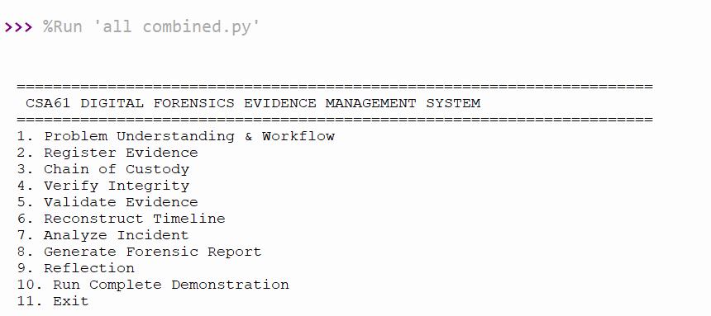
ENTERING CHOICE 1 :
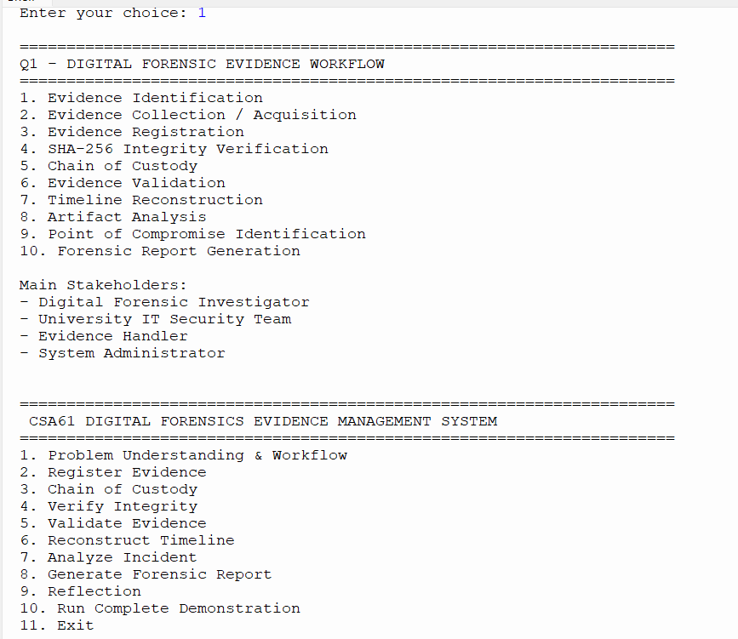

ENTERING CHOICE 2 :
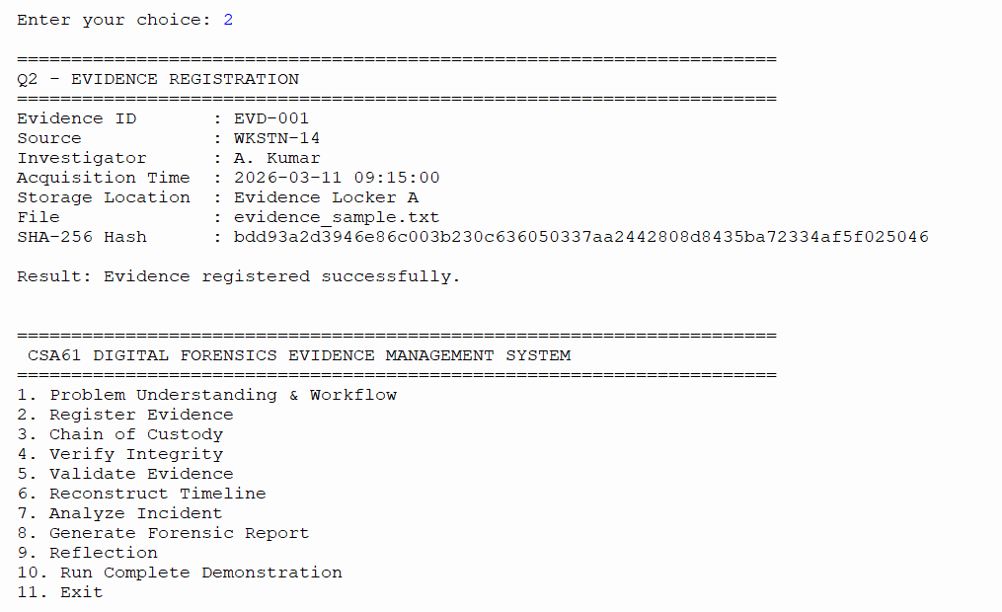
ENTERING CHOICE 3 :
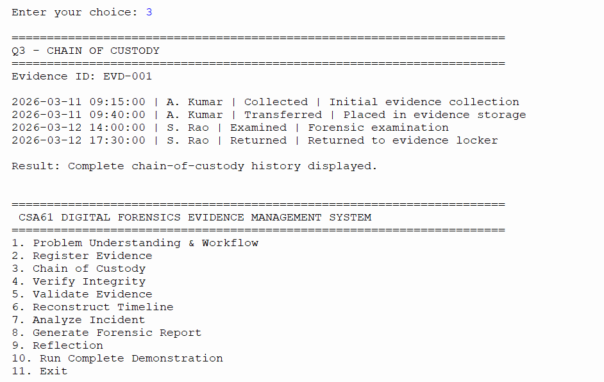
ENTERING CHOICE 4 :
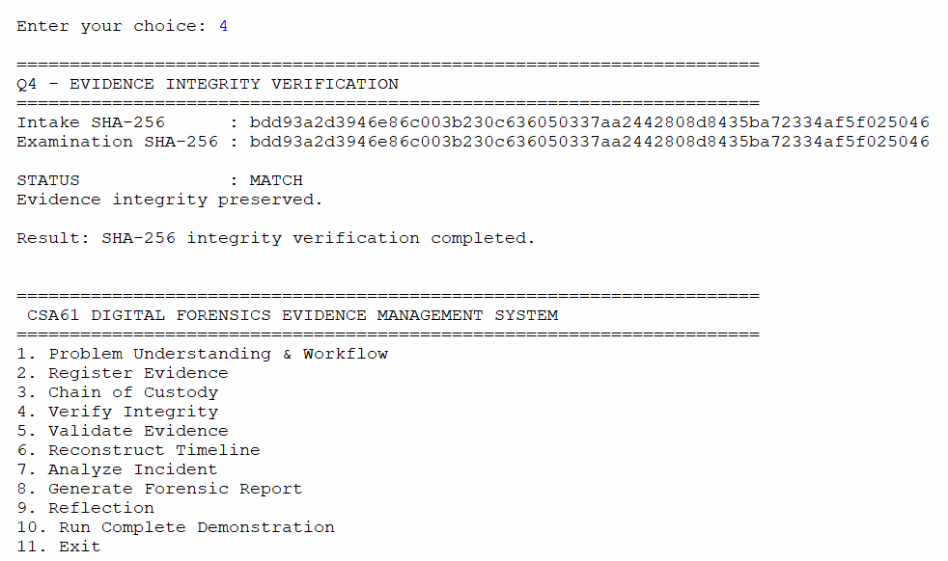
ENTERING CHOICE 5 :
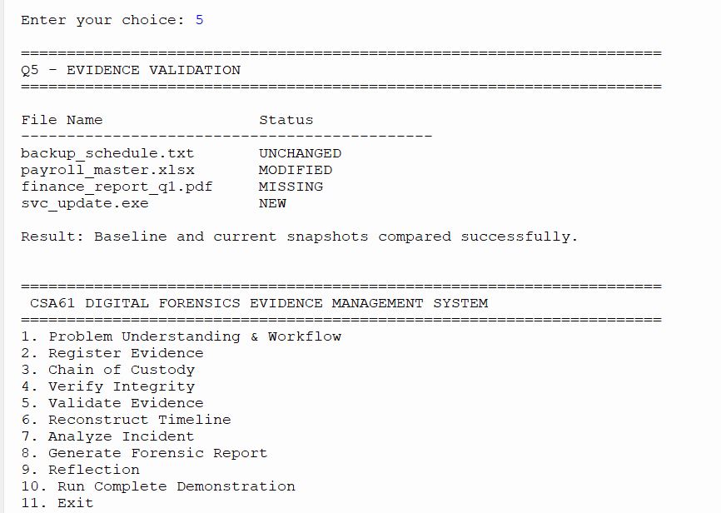

ENTERING CHOICE 6 :
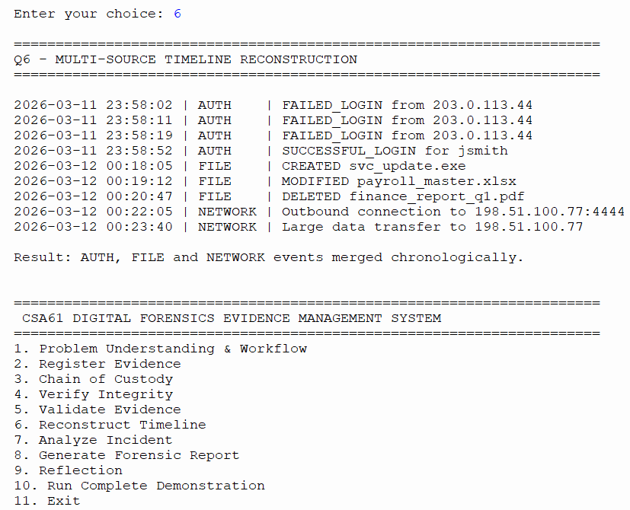
ENTERING CHOICE 7 :
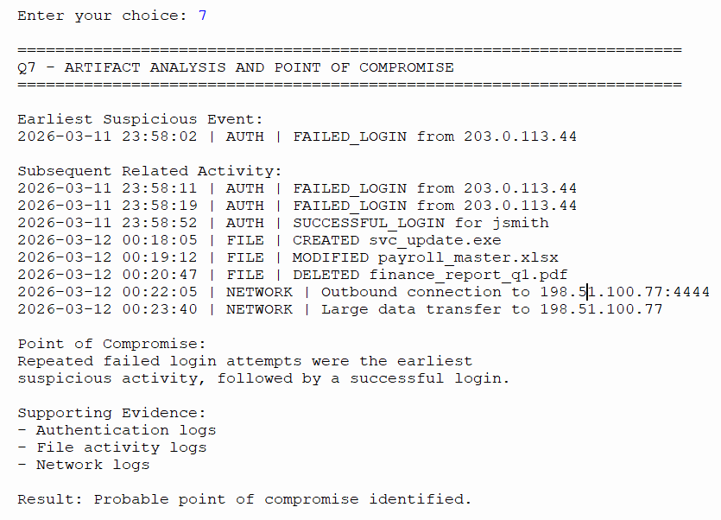

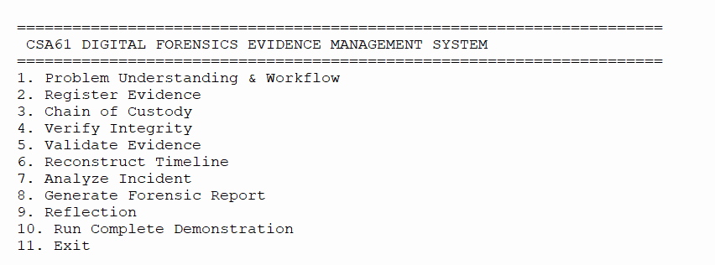
ENTERING CHOICE 8 :
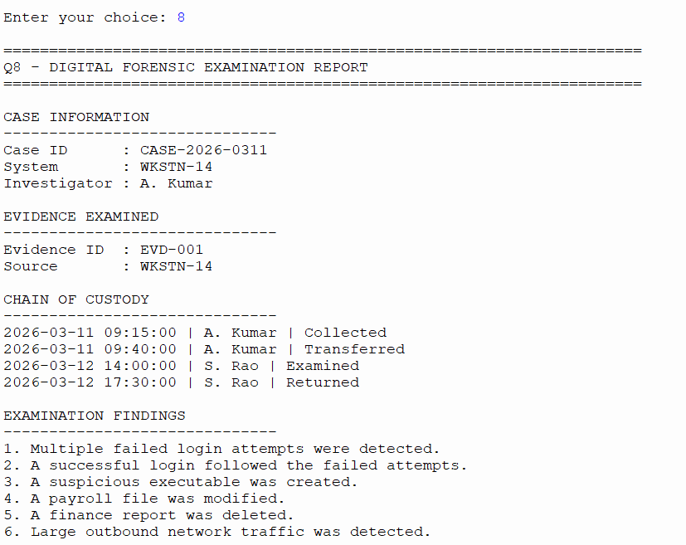
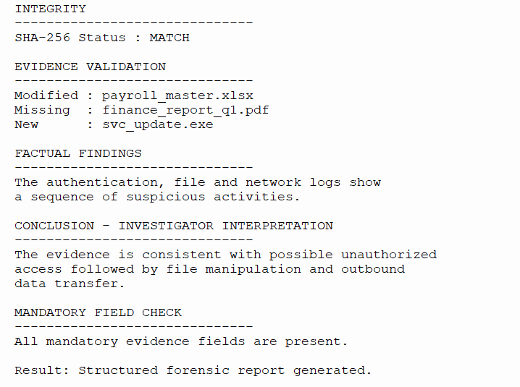
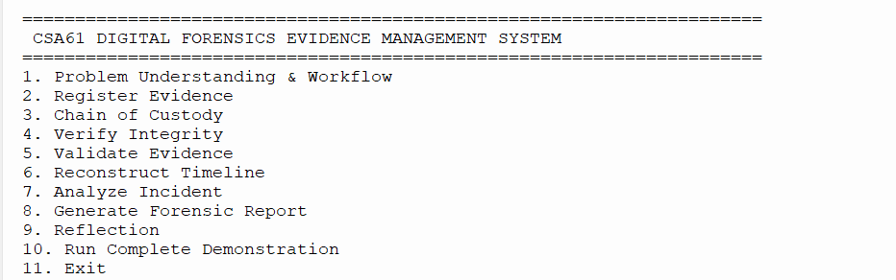
ENTERING CHOICE 9 :
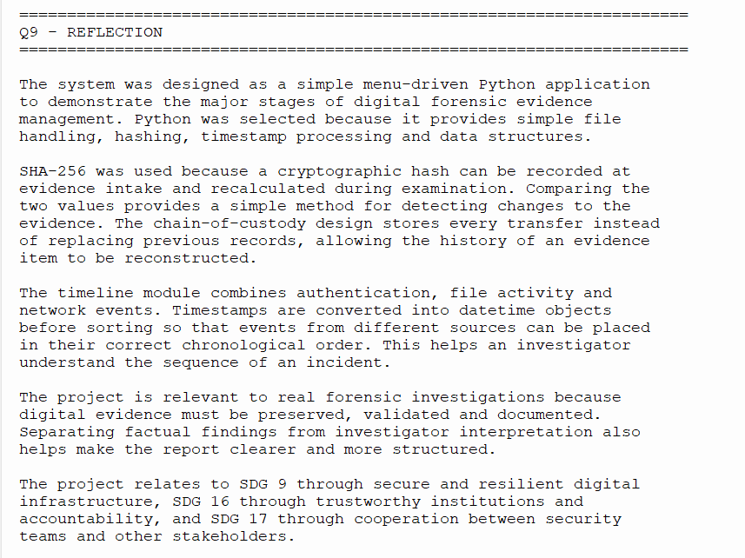
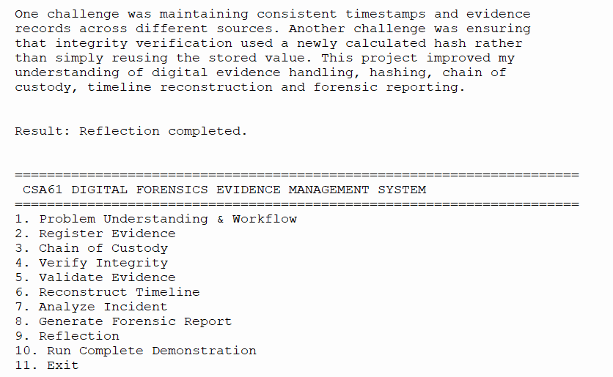
ENTERING CHOICE 10 :
COMPLETE DEMONSTRATION
ENTERING CHOICE 11 :
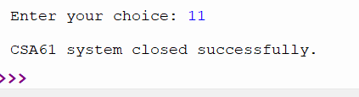
RESULT
The menu-driven Digital Forensics Evidence Management System was successfully designed and implemented in Python, covering the complete forensic evidence lifecycle from registration and preservation to analysis, incident reconstruction, and forensic reporting.

